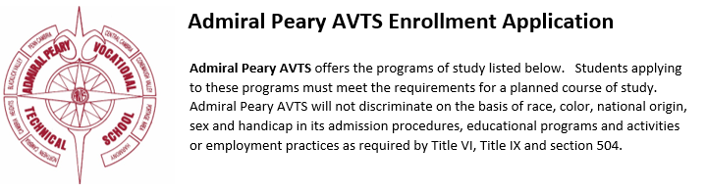

AUTO BODY/COLLISION REPAIR

AUTOMOTIVE TECHNOLOGY

CARPENTRY

COSMETOLOGY

CULINARY ARTS

DIESEL MECHANICS

EARLY CHILDHOOD TEACHER EDUCATION

ELECTRICAL TECHNOLOGY

ENGINEERING TECHNOLOGY

HEALTH ASSISTING

HORTICULTURE

HEATING VENTILATION AIR CONDITIONING / REFRIGERATION

MASONRY

NETWORKING TECHNOLOGY

SMALL ENGINE MECHANICS

WELDING

Enrollment procedure - Online Application:

https://ctcportal.csiu-technology.org/APAVTS/Form/Entry/AdmiralPearyOnlineRegistration45/PCSD/2022-2023

Student Name______________________________________________

Grade______________

Parent Signature_____________________________________________

